**DAILY ONLINE ACTIVITIES SUMMARY**

|  |  |  |  |  |  |
| --- | --- | --- | --- | --- | --- |
| **Date:** | **10/06/2020** | | | | |
| **Name of the Faculty** | **Shilpa** | | | | |
| **No. of Students Allotted for monitoring** | | | | **19** | |
| **Progress** | | | | **Good** | |
| **Whether collected report from all the allotted students** | | | | **15 submitted.** | |
| **Online Test Summary** | | | | | |
| **Subject** | | **Object Oriented Concepts [18CS45]** | | | |
| **Semester** | | **IV** | | **Duration** | **30 min** |
| **No. of students Taken** | | | **95** | **Passing %** | **65.26** |
| **Certification Course Summary** | | | | | |
| **Course** | 1. **Workshop on Machine Learning using Python** 2. **Workshop on Technical Document Preparation using Latex** 3. **National Level online FDP on PERL Scripting .** 4. **Webinar on Digital Image & Video Processing and its Applications** | | | | |
| **Certificate Provider** | 1. **NMAMIT, Nitte** 2. **Dr. S &S. S Ghandhy Government Engineering College, Surat.** 3. **Lords Institute of Engineering and Technology, Hyderabad.** 4. **IITM Janakpuri, New Delhi** | | | **Duration** | **4 days** |
| **Coding Challenges** | | | | | |
| **Problem Statement: -.** | | | | | |
| **Status: - 38** | | | | | |
| **Uploaded the report in Github** | | | | **YES** | |
| **If yes Repository name** | | | | <https://github.com/orgs/alvas-education-foundation/teams/2nd-year> | |
| **Uploaded the report in slack** | | | | **YES** | |

**Online Test Summary**

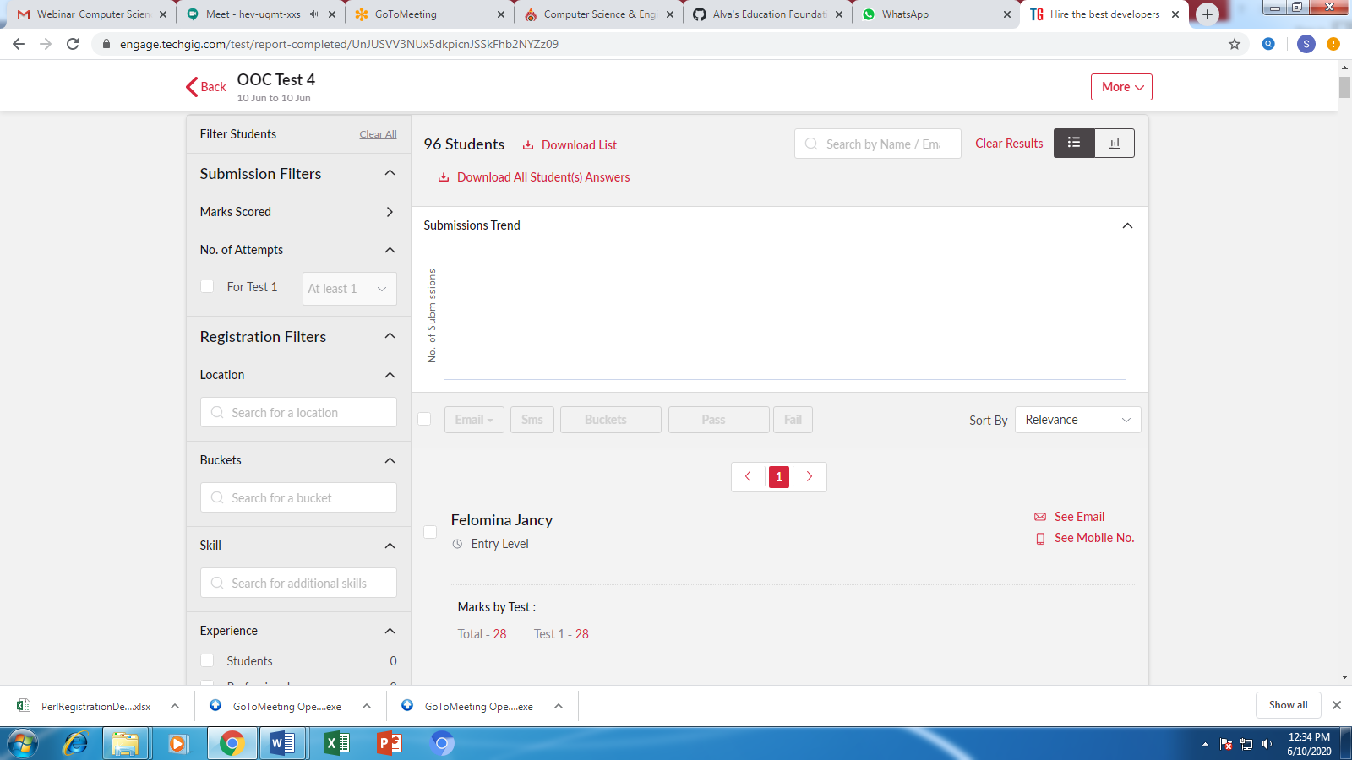

**Certification/webinar Course Summary**



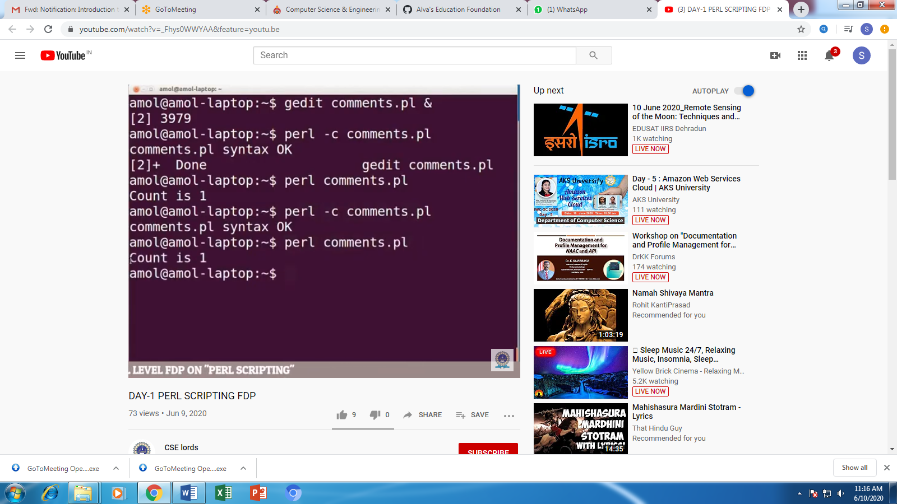

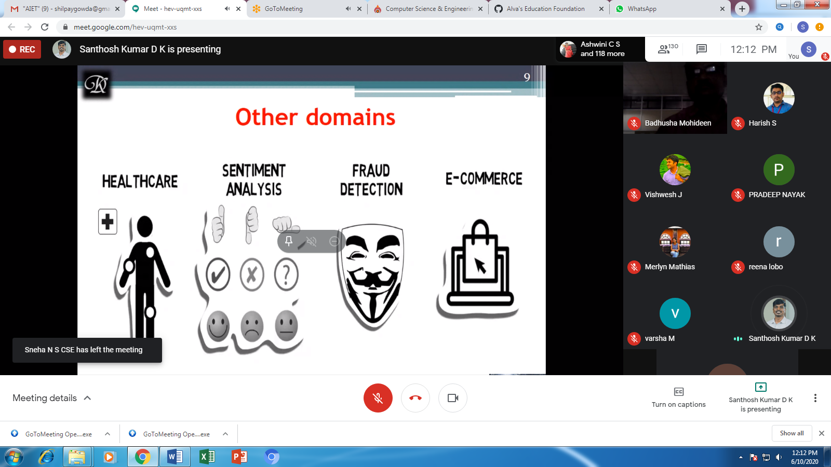

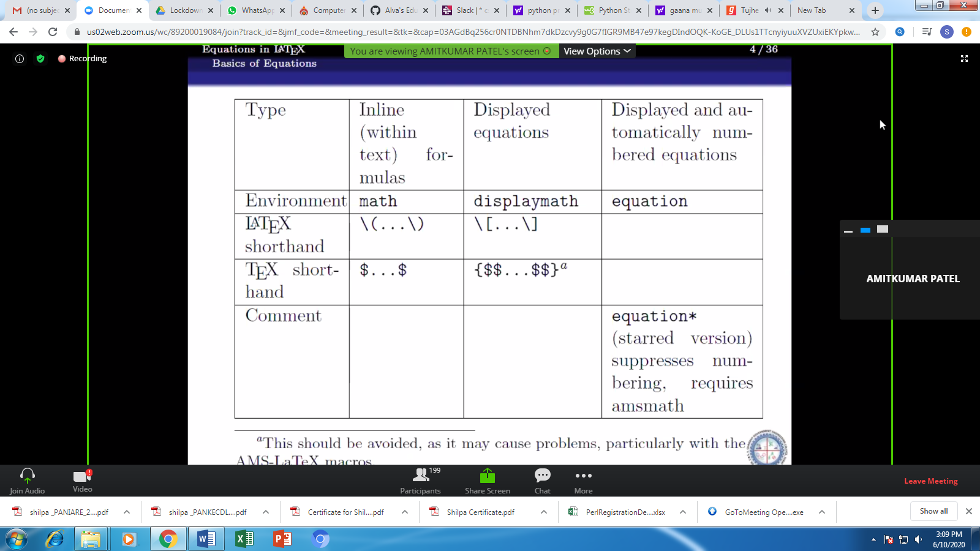

**Students Report:**

